NATIONAL UNIVERSITY OF MODERN LANGUAGES
Assignment # 03

SUBMITTED BY:
ZULQARNAIN HASSAN

SUBMITTED TO:
SIR. M WAQAR
Subject: ……………………………………….. data structure & algorithm
Roll No: ………………………………………… SP21379
Department: …………………………………. Software engineering
Section: …………………………………………. BSSE-III-A-afternoon

Answer N0 1

Write a function that can show the minimum and maximum elements in a binary search tree and update the value of a minimum element with some random value.
#include<iostream>
using namespace std;
struct node{
int data;
node* left;
node* right;
};
node* root=NULL;
void show(node*);
node *insert(node *,int);
main(){
root=insert(root,6);
root=insert(root,4);
root=insert(root,5);
root=insert(root,3);
root=insert(root,10);
root=insert(root,8);
root=insert(root,11);
show(root);

}
node *insert(node *root,int n)
{
if (root == NULL)
{
node *root1 = new node;
root1->data = n;
root1->left = NULL;
root1->right = NULL;
return root1;
}

else if (n < root->data)
{
root->left = insert(root->left,n);
}
else if (n > root->data)
{
root->right = insert(root->right, n);
}

}
void show(node* root)
{
node* root1=root;
while(root1->left!=NULL)
{
root1=root1->left;
}
while(root->right!=NULL)
{
root=root->right;
}
cout<<"\nthe minimum number in the binary search tree is: "<<root1->data;
cout<<"\n\nthe maximum number in the binary search tree is: "<<root->data;
root1->data=1;
cout<<"\n\nthe random updated value of the minimum number in the binary search tree is: "<<root1->data<<endl;

}
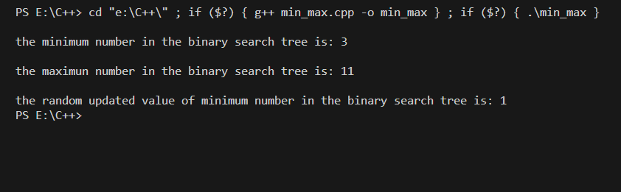

Answer N0 2
Suppose we have a binary search tree having integer number as its keys, write a function that calculate sum of all values of nodes in a binary search tree.

#include <iostream>
using namespace std;
struct node
{
int key;
node *left;
node *right;
};
node *root = NULL;
int sum(node *);
node *insert(node *, int);
main()
{
root = insert(root, 6);
root = insert(root, 4);
root = insert(root, 5);
root = insert(root, 3);
root = insert(root, 10);
root = insert(root, 8);
root = insert(root, 11);
int sum_of_values=sum(root);
cout<<"\n\nsum of all values of nodes in a binary search tree: "<<sum_of_values<<endl;
}
node *insert(node *root, int n)
{
if (root == NULL)
{
node *root1 = new node;
root1->key = n;
root1->left = NULL;
root1->right = NULL;
return root1;
}

else if (n < root->key)
{
root->left = insert(root->left, n);
}
else if (n > root->key)
{
root->right = insert(root->right, n);
}
}
int sum(node *root)
{

if (root == NULL)
{
return 0;
}

return root->key + sum(root->left) + sum(root->right);

}
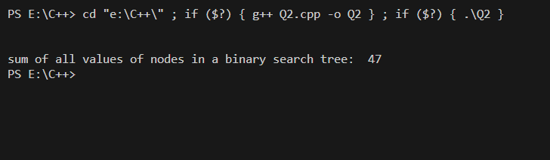

Answer N0 3

Write a function that can only show leaf nodes present in a binary search tree.
#include <iostream>
using namespace std;
struct node
{
int key;
node *left;
node *right;
};
node *root = NULL;
void printLeafNodes(node *);
node *insert(node *, int);
main()
{
root = insert(root, 6);
root = insert(root, 4);
root = insert(root, 5);
root = insert(root, 3);
root = insert(root, 10);
root = insert(root, 8);
root = insert(root, 11);
cout<<"leaf nodes are\n";
printLeafNodes(root);

}
node *insert(node *root, int n)
{
if (root == NULL)
{
node *root1 = new node;
root1->key = n;
root1->left = NULL;
root1->right = NULL;
return root1;
}

else if (n < root->key)
{
root->left = insert(root->left, n);
}
else if (n > root->key)
{
root->right = insert(root->right, n);
}
}
void printLeafNodes(node* root) {
if (root == nullptr)
return;

if (root->left == nullptr && root->right == nullptr)
std::cout << root->key << std::endl;

printLeafNodes(root->left);
printLeafNodes(root->right);
}
